PROJECT REPORT

INTRODUCTION

**OVERVIEW** **:**

This project is helps to measure , manage and improve ,the strategic role of the

HR Department the HR Scorecard is meant to measure leading HR indicators are

Measurements that predict future business growth. This data is also used to

Predict the potential growth of the organization.

purpose:

Scorecards offer organizations a snapshot of their current performance when

Of this current performance when compared to their goals. They we useful tools.

For organizations which need to manage performance and make strategic

Decisions better based on the distance between current performance and the

Goal. This Scorecard can be used to guide the design of performance reports

and dashboards.

PROBLEM DEFINITION & DESIGN THIKINGS:

EMPATHY MAP

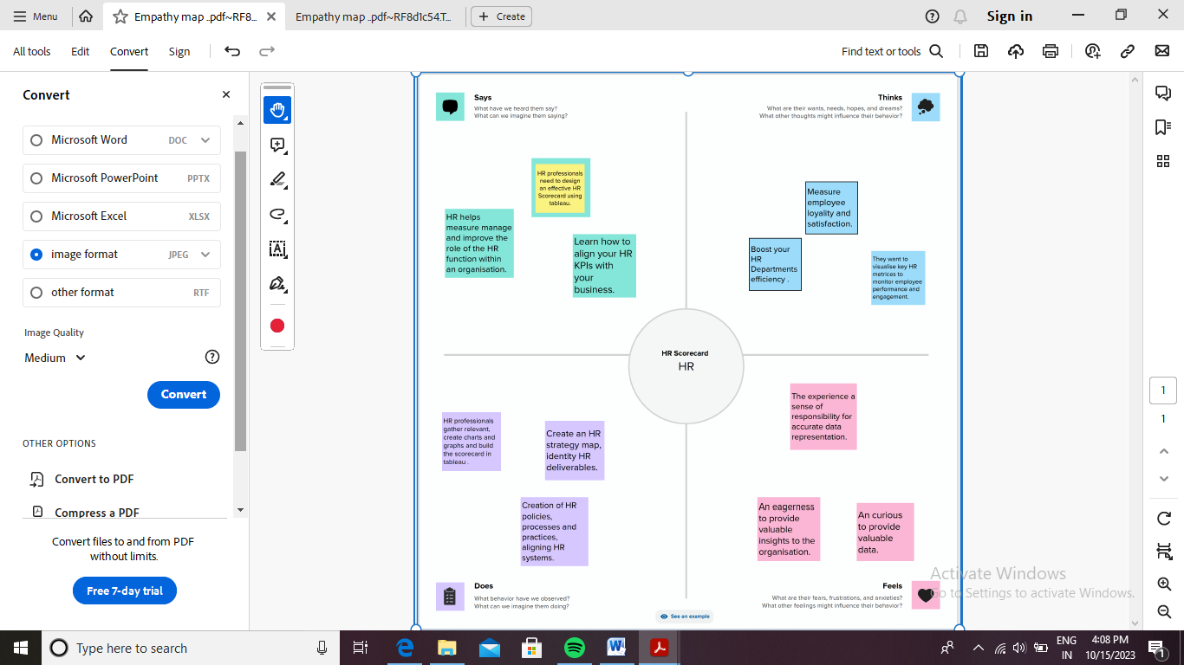

BRAINSTORMING MAP:

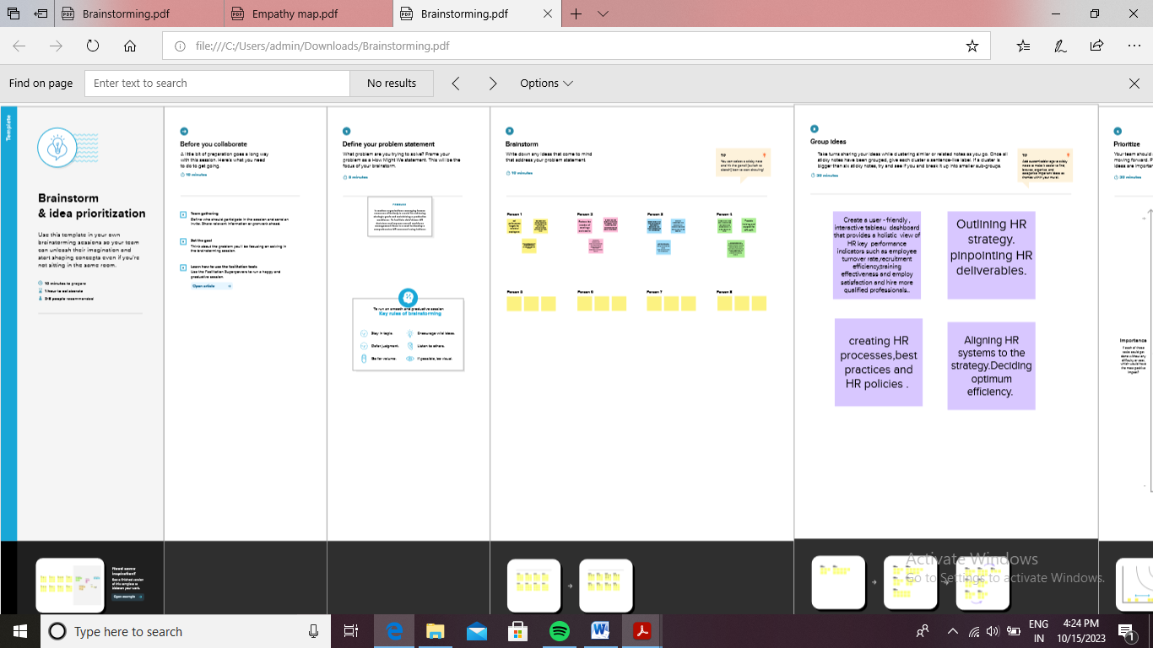RESULT:

SCREENSHOTS:

DASHBOARD 1

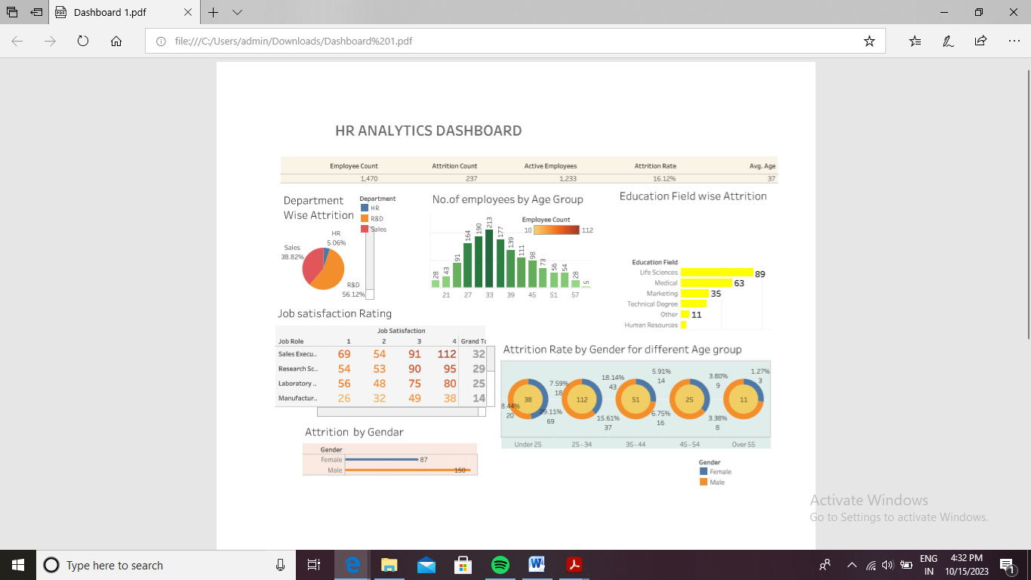

STORY:

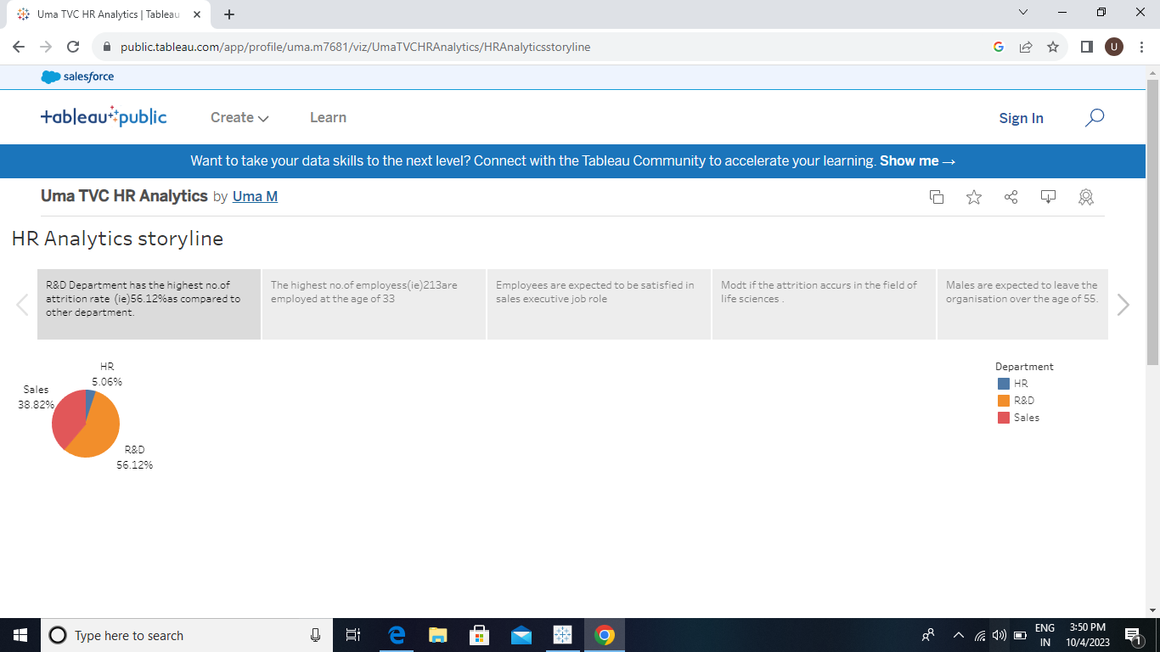

KPI

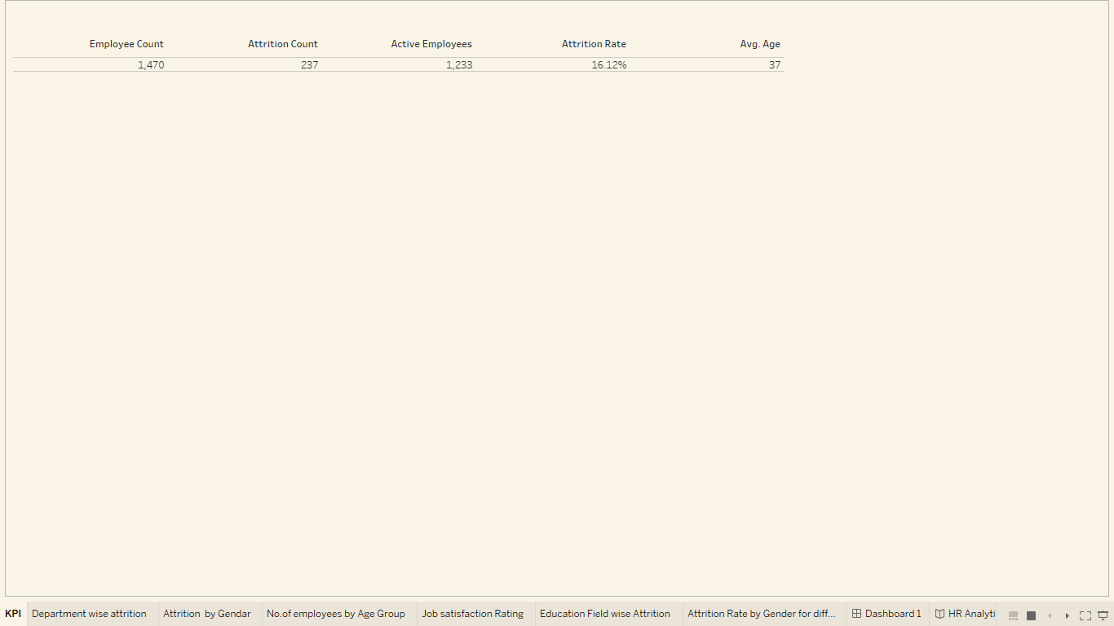

Department wise attrition

a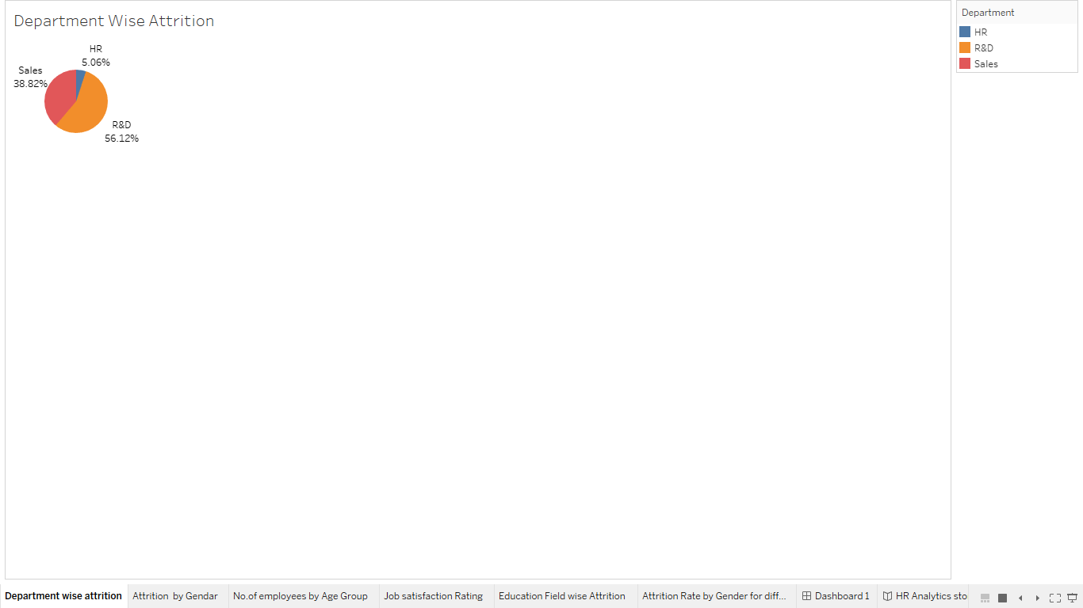

Attrition by gendar

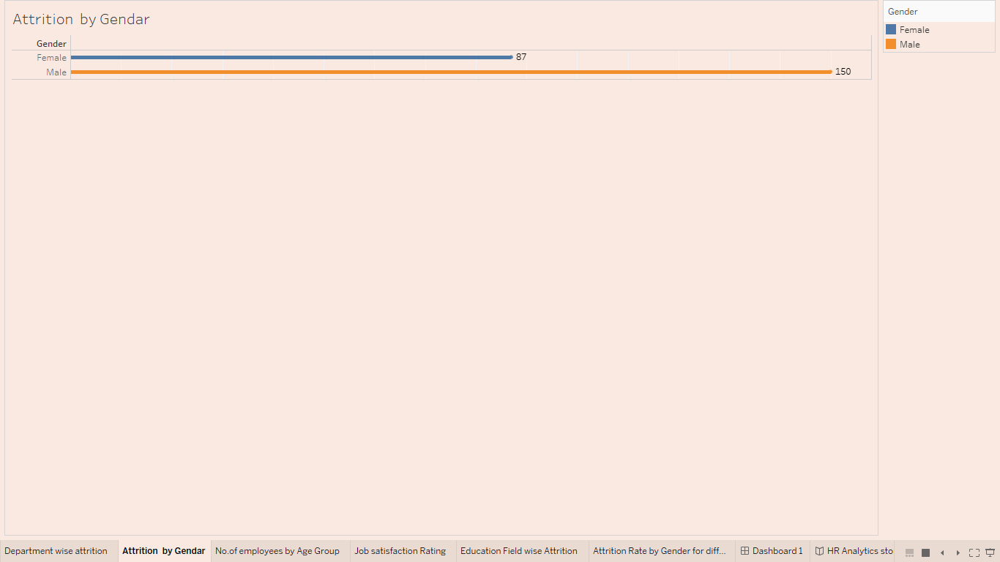

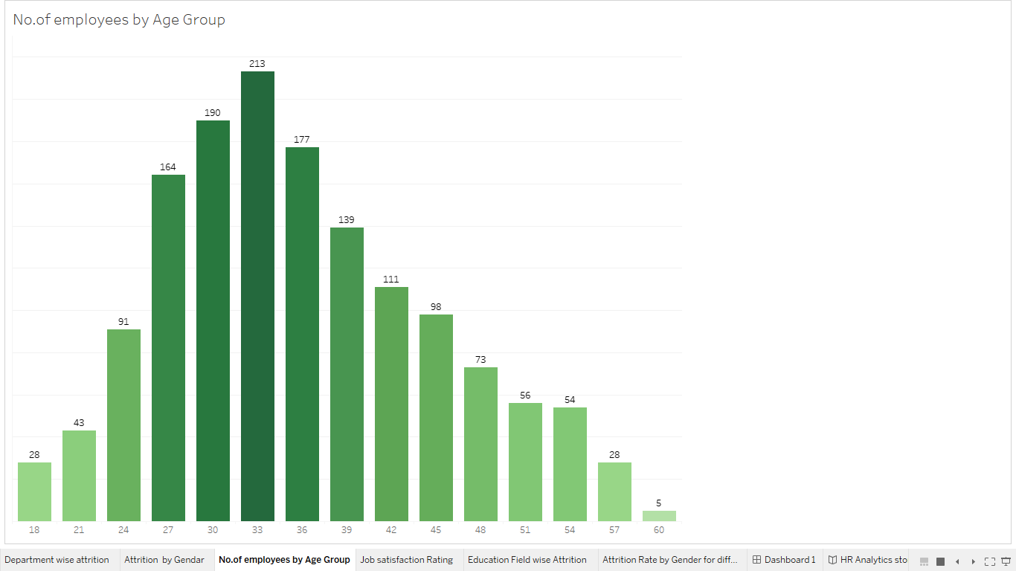

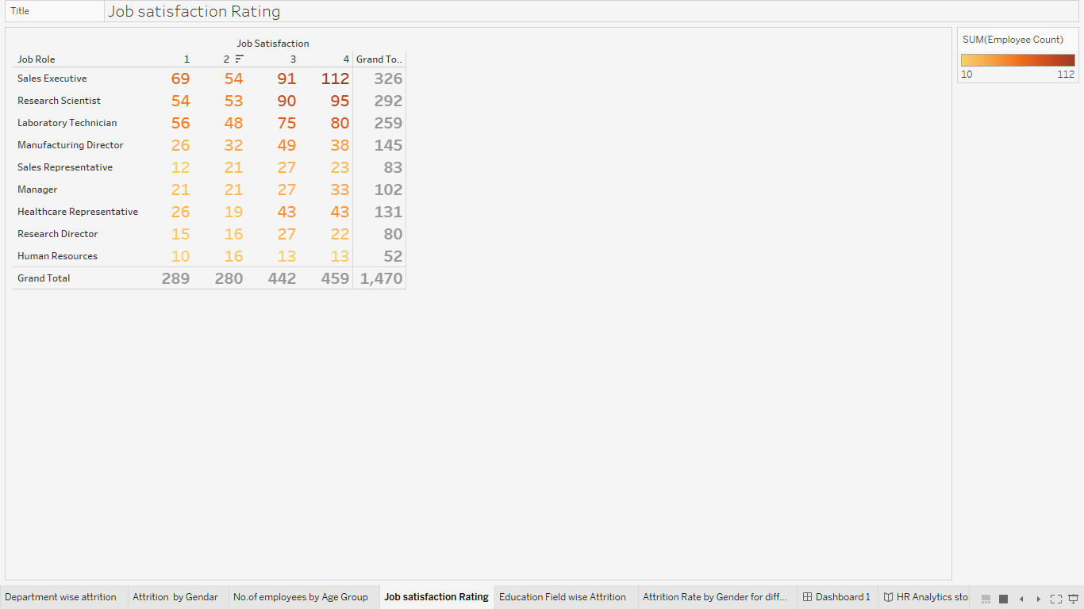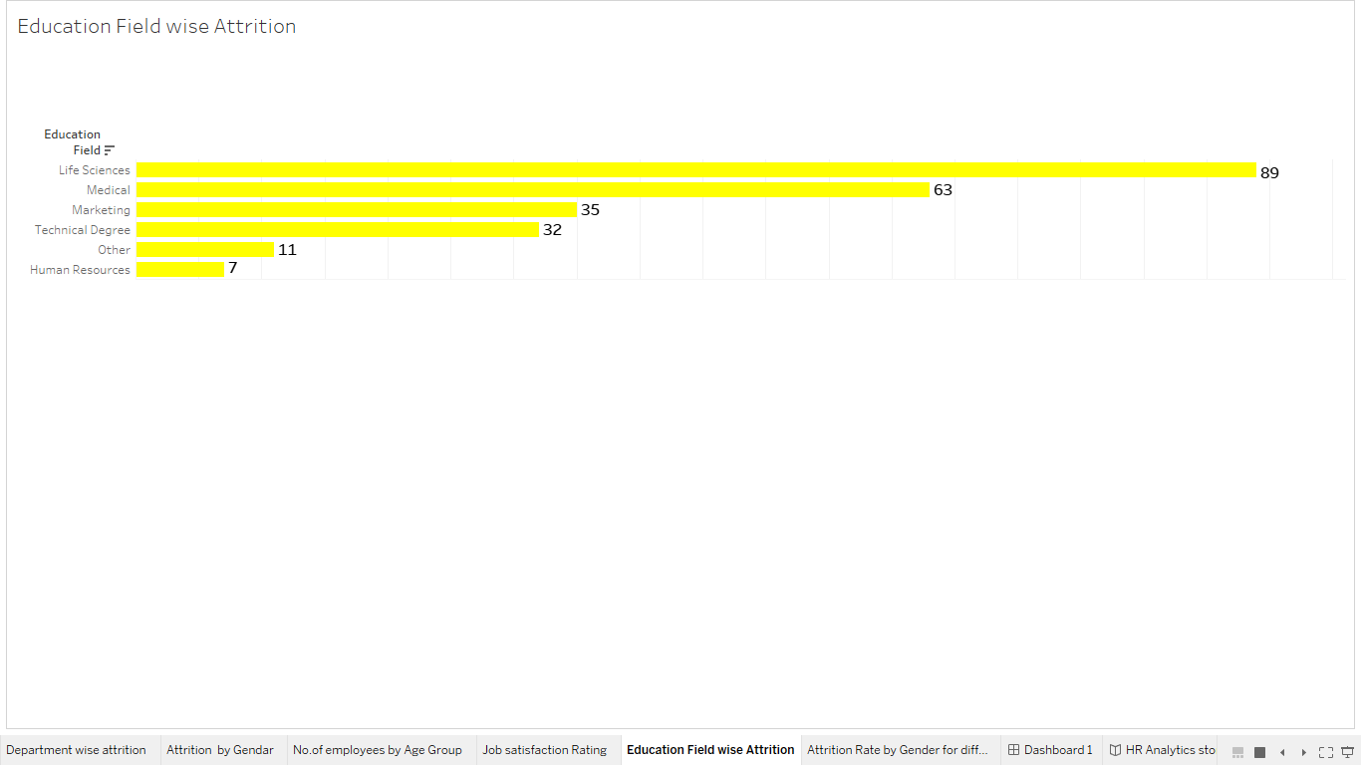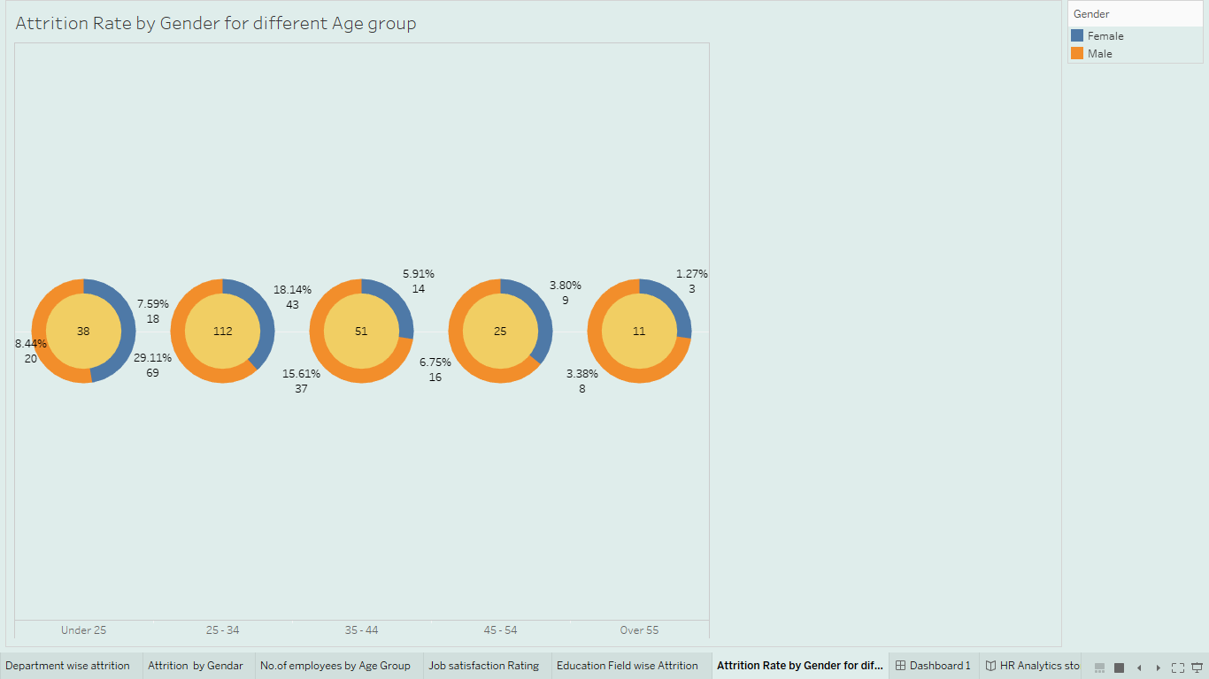

advantages & Disadvantages

Effective scorecord link performance to the organizations overall performances and goals. This lintage can help in communicating performamce and results to the various stakeholders. A welldesigned and balanced scorecard with solid supplymentary proceeses will help increase accountability.

The scorecard gives structure to the strategy , improves performance reporting , Makes it easier to communicate ,connect every HR employee to organizational goals , define your goals and objectives the most important advantages include the ability to bring information into a single report , which can save time,money and resources.

The disadvantages of the HR scorecard are,

1.It can be an overwhelming framework.

2.It requires strong leadership support to be successful.

3. Lack of clarity and alignment.

applications :

Applications of HR Analytics are required in the field of statics , analytics ,and modeling of employee related factors to imprve business results .Analytics can help you determine which qualities are most important for a certain position ,than sift through applications and find the candidates that best match those qualifies.

HR analytics allows HR professionals to make data driven decisions to manage attract and retain employees ,improving ROI . It helps managers make decisions about creating better work environments and maximizing employee productivity. It has a big impact on the finish line when used effectively. Other such applications are ratension , employee performance ,recruiting , employee development , workforce planning , employee engagement,compensation and incentive programs.

conclusion:

The HR Scorecord focuses attention not only on the financial objectives of the company but also highlghts the non-financial obectives that an organization must achieve in order to must its financial objectives .

The HR scorecard plays a crucial role in measuring and improving employee engagement .By tracking metrices such as employee satisfaction , performance feedback and career development oppurtunities HR Leader gain insights into the factors that impact employee engagement.

HR Scorecard is a report that you conduct to calculate the success rate of human resource employees and the overall department .Any HR profeesional looking to judge and assess the business performance and productivity rate can start making use of this report to get valuable insights into the work progress.

HRM ,Whenmanaged correctly ,isa vital part of an organization and it’s success HR must be a strategic business partner in order to survive in this century. Basic knowledge of the HR functions is needed by all management

future scope :

The future of HR Analytics is all about leveraging data to make informed decisions related to the workforce .By measuring ,analyzing ,and interpreting HR metrices and data ,organizations can gain valuable insights into employee performance ,engagement ,turnover and more.

With statistical techniques ,data mining , machine learning ,and predictive analytics ,HR Analytics can help organizations identify and address workforce issues before they become major problems.

This data –driven approach to workforce management can lead to improved decision making ,better recruitment and retension stratigies ,and ultimately ,a more engaged and productive workforce.

As the use of HR Analytics continues to grow ,it will becoe an increasingly important tool for organisations looking to stay ahead of the curve and make data-driven decisions for the future.